Double click on beta_simulator . It will show following screen. Click on Play!.

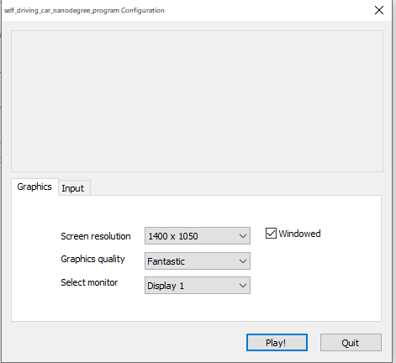

After clicking Play!, following screen is displayed. Select Autonomous mode and Select any one of track by clicking on them.

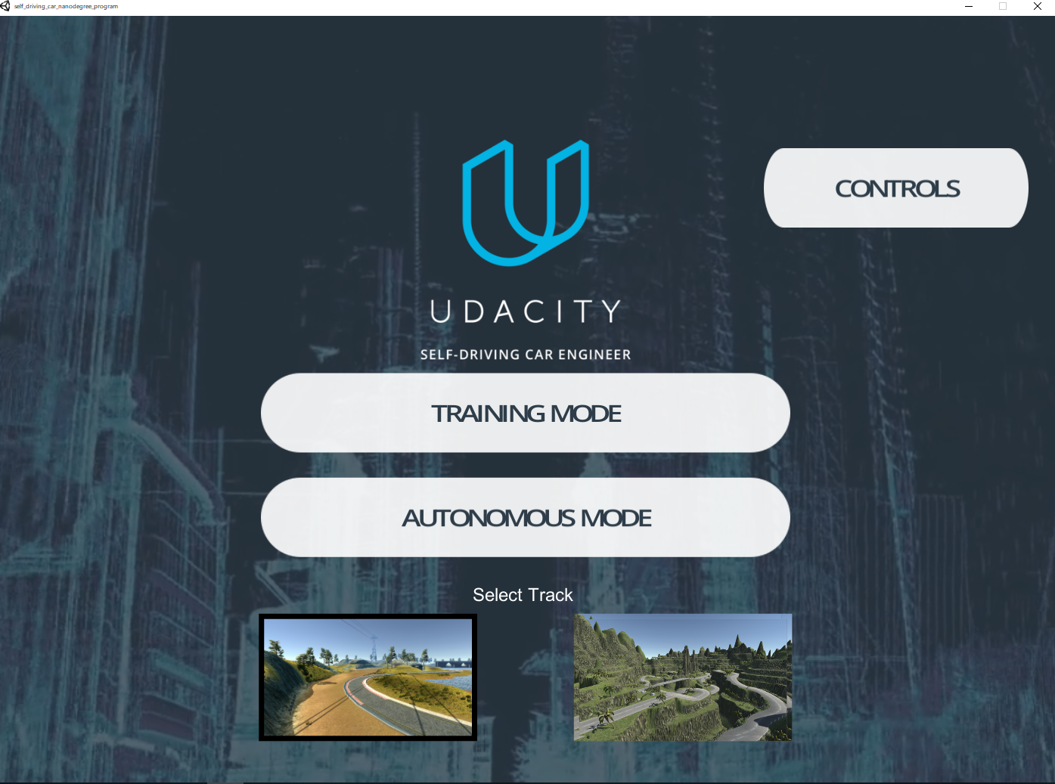

It will show the car but it will not move. To move the car we will use an artificial intelligence based model which tell the car at what angle to move the wheel and at what speed to move.

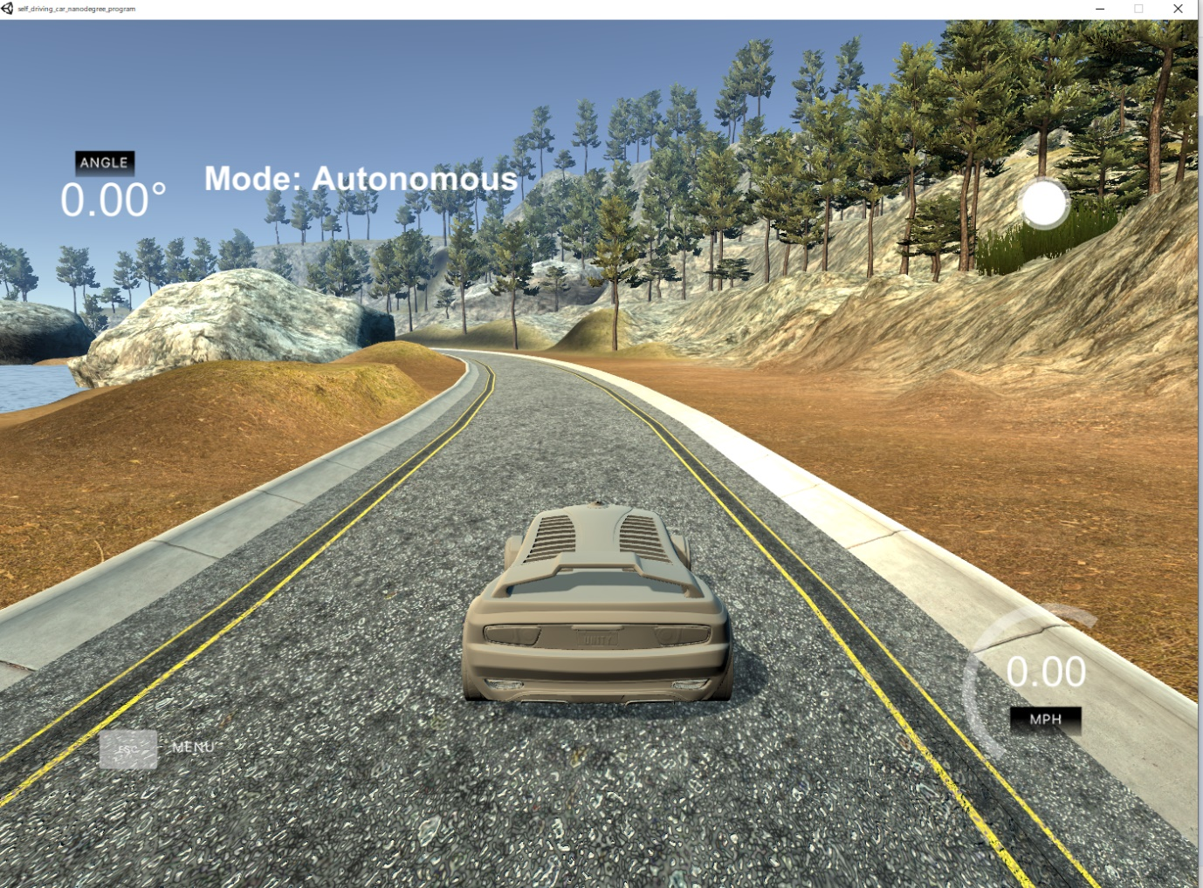

**To move the car:**

Open the anaconda prompt. Run following command

**cd C:\Users\User\Desktop\Workshop20Nov\Self-Driving-Udacity-Simulator**

after directory is changed run following command

**conda activate car-behavioral-cloning**

Once the environment is activate, run following command.

**python drive.py model.json --speed 50**

It might take some time to connect but once it connects it will start printing angle on screen and you can view in the simulator window that car is moving now.

If it bumps into wall Press Esc and start again by clicking on autonomous and selecting the track.